Musket Tools – Part 1: Private’s Tools
Corporal Steve Blancard

Maintaining your musket is one of the most important things a soldier can do. A musket should be your best friend, but failure to take proper care of it can turn it into your worst enemy. Over the next few months we will discuss different aspects of musket maintenance, focusing on the Springfield/Harpers Ferry/Richmond pattern muskets. Most of what follows applies to Enfield muskets as well. Today we are going to talk about implements - the tools that were issued with a musket and used by a soldier to maintain his musket in the field.
Let’s look at what the Ordnance department had to say. An extract from the Rules For The Management and Cleaning of the Rifle Musket, Model 1855 handbook states: “The officers, non commissioned officers and soldiers should be instructed and practiced in the nomenclature of the arms, the manner of dismounting and mounting them, and the precautions and care required for their preservations. Each soldier should have a screwdriver and a wiper, and each non-commissioned officer a wire and a tumbler punch and a spring vise. No other implements should be used in taking arms apart or in setting them up. In the inspection of arms, officers should attend to the qualities essential to service, rather than a bright polish on the exterior of the arms. The arms should be inspected in the quarters at least once a month, with the barrel and lock separated from the stock.”
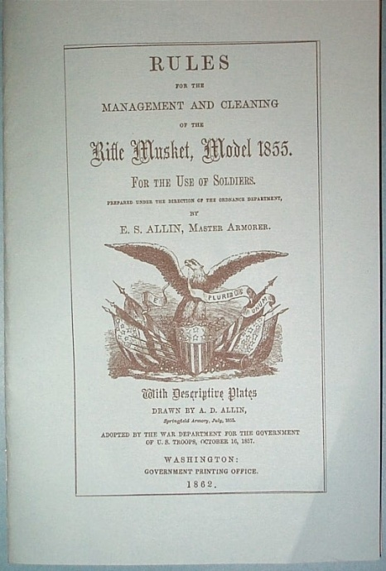
In order to perform proper field cleaning of a musket per the model 1855 rifle musket manual, only two basic tools are needed by a soldier – a wiper (often improperly called a worm) and a screwdriver (often called a musket wrench). The wiper threads onto the end of the ramrod and is used to hold a piece of cloth for wiping the bore. The screwdriver is actually a multi-function tool that is used to:
- Remove the cone (often improperly called a nipple)
- Remove the bolster clean out screw (model 1855/1861)
- Dismount the musket (only if necessary or monthly) which includes removing the lock and barrel from the stock.
Reproductions of most of the different screwdriver/musket tools and wipers of the period are available from sutlers. This includes the US model 1841/1842 tool, the US model 1855 tool and the US model 1863 tool. Conspicuously absent among reproduction tools is the Confederate made “T” handle tool. Most of the reproduction tools I’ve seen are serviceable, but they sometimes need a little tuning to work with our reproduction muskets of Italian decent.
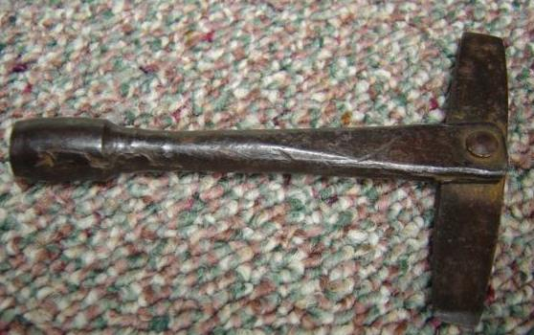
Original Confederate musket tool

We refer to them as musket tools because they don’t look like a conventional screwdriver and they serve several functions. Musket tools typically have either two or three screwdriver blades on them. Each is sized differently to fit various screws. Note that the large blade on the 1855 and 1863 tools is slightly convex at the end. This is to fit original butt plate, trigger guard and side lock screws which had a corresponding concave slot. The purpose of this was to reduce the chance of the blade slipping from the screw slot and injuring the soldier. The smaller blade is for internal lock screws. The 1855 tool has three blades, the extra small one is for the tiny bolster clean out screw used on US model 1855 and 1861 muskets.
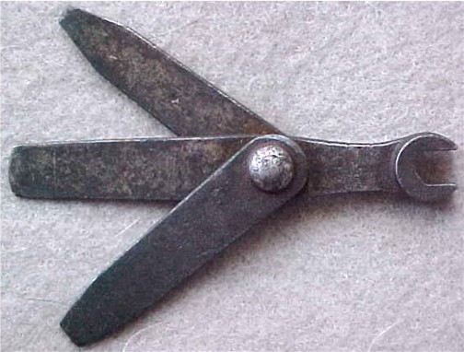
US model 1855 tool
The biggest problem with these tools is that the screwdriver blades are often too thick to fit the screws on reproduction muskets. It’s actually not a problem with the tool, but with the muskets. Both the Italians and Japanese like to use very narrow slots in their screws. While they look elegant, they cause difficulty when trying to use original style tools. This problem is most easily addressed by carefully grinding the screwdriver blade tips to a narrower profile. Reproduction muskets generally do not use concave slots on the screws mentioned earlier, so it’s best to grind that blade’s end square. The cone wrench part of the tool is usually serviceable, but may need a little work with a file to fit the square shank of a modern cone. Notice that the M1841 Mississippi rifle /1842 wrench has a closed or box end wrench, while later tools have open cone wrenches – ever wonder why? It’s because the design of the model 1855 rifle-musket lock and breech is very close around the cone when compared to the US model 1841 and model 1842 musket. The closed end wrench won’t fit around the cone of a model 18855, 1861 or Richmond.
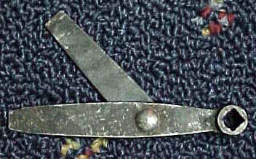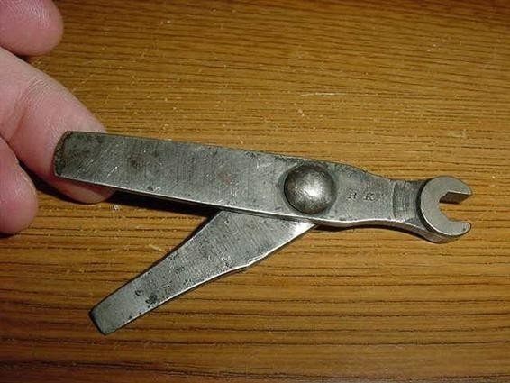
US model 1841/1842 tool US model 1863 tool
Now let’s look at wipers. There are some pretty good ones out there (and some lousy ones). However, sometimes the diameter of the spirals are a little large. When used with modern cleaning patches, they can be too tight in the bore. This can result in a wiper/ramrod being stuck in the bore and a rather embarrassing trip to the regimental ordnance sergeant to have it removed. I’ve noticed this particularly with the reproduction US .58 cal. wipers. To resolve this, I take them to a grinder and carefully reduce the outside diameter of the spirals by about .020”-.030”. Original .69 cal. wipers are still available from several sutlers. I’ve found these to work fine in my repro .69 cal. smoothbores with no modification. The other thing to watch for on wipers is the thread size. Original US model ramrods were made with a thread very close to 12x24. Reproduction ramrods are often 10x32 threads, some Japanese made reproduction musket ramrods use 12x24. The bottom line here is to make sure you get the correct threaded wiper for your ramrod.
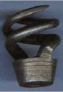
Original US .69 cal wiper
As a side note, all muskets manufactured by either Springfield, Harpers Ferry armories up through the 1890s use metric threads on every part except the cone, which uses a US standard 5/16”-24 size thread. Surprised? Most people are. This was a carryover from the days when the national armories initially geared up to produce their first musket; the so-called US model 1795. This was essentially an exact copy of the French Charleville model 1768 musket, which used metric threads. The armories copied them exactly.
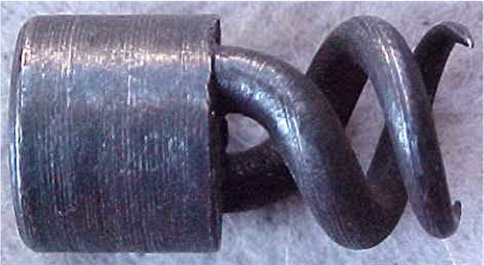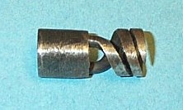
Original early war US .58 cal wiper US .58 cal. wiper ground to fit

So now we know that there are only two implements that the Ordnance department entrusted to privates; the screwdriver and wiper. Next time, we’ll look at the tools non-commissioned officers were allowed to use; the spring vise, and tumbler and wire punch and the Enfield sergeant’s tool.

