Musket Lock Maintenance – Part 2: Cleaning and Inspection
Corporal Steve Blancard
In the last newsletter we walked step by step through the disassembly process of a typical Springfield musket lock. Today we will discuss what you do with all those pieces and how to prepare them for reassembly.
Now that your lock is broken down, it’s time to give it a good cleaning. If it has been a few seasons or longer, there is likely to be a build-up of dirt, powder fouling and/or rust on some of the parts. If there is any grease left on the tumbler, it has probably mixed with the dirt to form an abrasive compound that needs to be removed. Clean all the parts in some hot soapy water and dry thoroughly. If rust is still present, clean it off with some 0000 steel wool or if it is real bad, some 400 grits wet/dry sandpaper. Once all your parts are clean and dry it time to give them a close inspection. Inspect all the parts closely for wear, cracks or other damage. Look especially close at the nose of the sear (the part that engages the half and full cock notches on the tumbler). Both parts should be hardened, but generally the sear is a little softer than the tumbler. The sear tip should have a crisp, flat edge that engages the tumbler. If it looks worn, rounded or damaged, replace the sear. Below are two photos that show the interaction of the sear and tumbler at both the half and full cock positions (bridle removed for clarity).

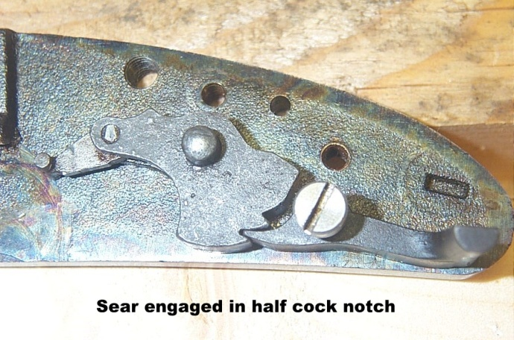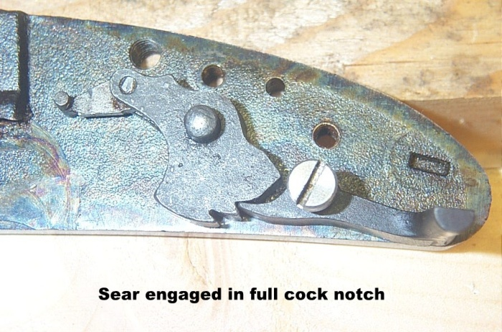
Look closely at the half and full cock notches on the tumbler. They should be sharp and crisp as well. The full cock notch is flat which allows the sear to be pulled off it when the trigger is pulled. Sharp, crisp edges on the sear ensure that it will not slip off full cock accidently. The same goes for the full cock notch on the tumbler. In the half cock position, the sear nose fits in the half cock notch. The lip of the notch keeps the sear from disengaging if the trigger is pulled. If that lip is chipped or broken, the musket is not safe to use and the tumbler must be replaced. The fitting and condition of these two pieces are critical to the safety of the musket.
The mainsprings on most Italian made muskets are made from cast steel, not forged steel as the originals were. Casting is a more efficient (read cheaper) way to produce large flat springs. However, cast springs are more prone to breakage than a forged spring. Look for small cracks around the “U” bend of the spring. Sear springs are made of sheet spring steel and are usually pretty reliable. But it’s a good idea to keep a spare main and sear spring in your kit, just in case.
How was the fit of the hammer onto the square shank of the tumbler? If it was snug with no slop, that’s good. If the hammer was loose on the tumbler, then there is a problem. If this is the case, the best thing to do is order a new tumbler and hammer together and replace them as a pair. In a pinch, there are ways to tighten up this slop, but this is beyond the scope of this article.
Another thing to look at is the clearance between the tumbler and the bridle. Insert the tumbler into the lock plate, then attach the bridle with the bridle screw, sear and sear screw, no need for the sear spring at this point.
A note on sear screws - on original Springfield sear screws the threads end with a small shoulder at an exact location. There is a very good reason for this. As the screw is tightened the shoulder stops the screw at a predetermined point. Without this shoulder, the screw can be overtightened, pulling the bridle down against the tumbler, causing the tumbler to be pinched. Unfortunately, most Italian manufacturers omit this shoulder on their screws. I have seen many reproduction musket locks with the sear screw either over tightened or intentionally left loose, neither of which is desirable or safe. In the third part of this article, I’ll discuss how to resolve this problem.
With the above note in mind, gently tighten the sear screw until the screw head just snugs up against the bridle – then stop. With the 2 screws snug, verify that the tumbler rotates freely with no binding. If it binds, there is a problem that needs to be fixed. Usually, these parts are properly matched at the factory, but not always. One of our members had a musket with a tumbler that did not have proper clearance and it caused the musket’s hammer to freeze up when firing. I ended up having to remove about .020” from the underside of the bridle in order for it to have proper clearance. It has been working fine ever since.
All your lock parts should now be in good condition, clean, free of rust and ready to go back together. In the next newsletter well walk through lubrication and assembly of the lock.

