Musket Lock Maintenance – Part 1: Disassembly
Corporal Steve Blancard

This is the first of a three part article on musket lock maintenance. These articles will appear in succeeding newsletters. Part #1 will discuss lock disassembly, part #2 cleaning and inspection and part #3 lubrication and assembly. Unless you are familiar with this procedure, it is recommended that you read and print all three parts before performing this maintenance.

Ok, be honest – have you every disassembled your musket’s lock for maintenance? Been a long time…maybe never? I suspect that most reenactors have never done it. All good soldiers know how to clean their musket after a weekend of battling the Yankee invaders. But after the bore is clean, dry and oiled and the outside is wiped down with an oily rag, the soldier’s best friend is often stood in a closet until the next event. That’s all well and good. But for a musket that is used routinely in the field, the lock should be removed and completely disassembled for cleaning, inspection and lubrication once a year. This is because fouling, dirt and rust will accumulate inside the lock. These contaminants mix with any lubrication that was there and turn to a grinding paste. This can lead to excessive wear and an unsafe lock.
While our muskets are modern reproductions, the basic lock design is over 250 years old. These locks have proven to be rugged and dependable; however like all things mechanical, they need some maintenance from time to time. In part #1 we will go through the step by step disassembly of a Springfield Model 1863 lock. While you may have another model, the basic design is the same and you should have no problem following along with your lock in hand. We will also use the standard musket tools discussed in previous newsletters. Here is a diagram of a musket lock with all the internal parts labeled, note the names and location of all the parts.
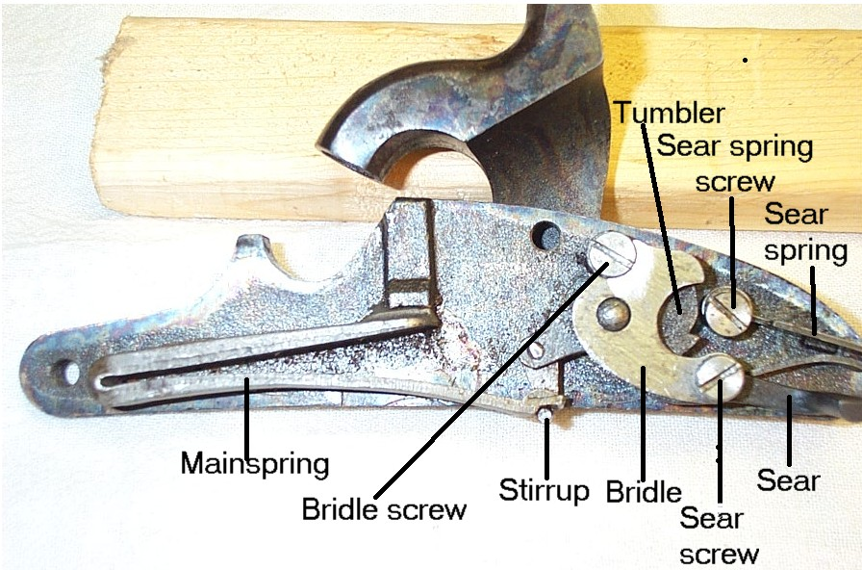
First off, the lock must be removed from the stock. Some locks are a tight fit and need to be carefully coaxed out.
Step #1 – Place the hammer in the half-cock position. This does two things; it ensures the hammer nose will clear the cone as the lock is removed and prevents damage to the stock as the lock comes out. More on this shortly.
Step#2 – With a properly fitting musket wrench (screwdriver blade) unscrew both lock retaining screws on the left side about 2 turns, being sure to leave the screw threads partially engaged in the lock. Now take a non-marring hammer or block of wood and gently tap on the screws alternately to push the lock part way out of the stock. This will break the lock loose from a tight stock. Remove the lock screws completely and remove the lock from the stock.
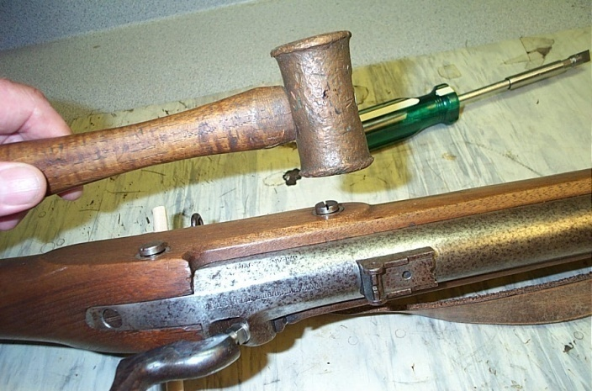
With the lock in your hand, pull back the hammer slightly, press up on the sear and lower the hammer to the rest position. Now look at the lock in the photo below. Notice that at the bottom of the lock, the end of the mainspring attached to the stirrup hangs down below the bottom edge of the lock plate. If you had tried to remove the lock with the hammer all the way down, that protruding piece would have dug into the stock as you removed the lock causing damage to the wood. This is why it is so important to put the hammer at half cock before removing the lock. Not all locks will do this, but originals and some reproductions will.
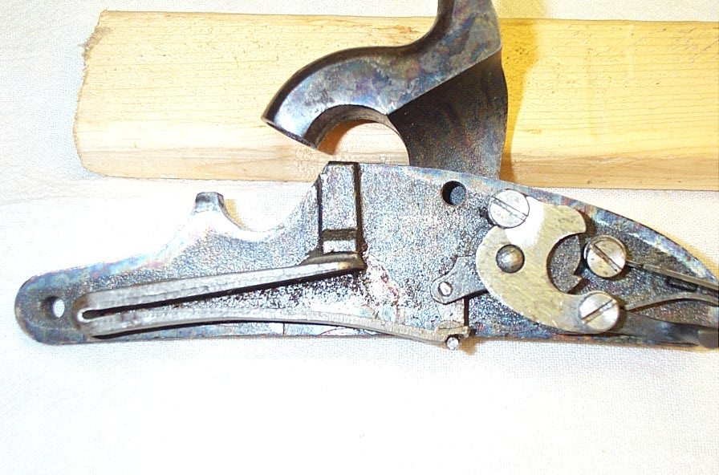
Step #3 – Put the hammer on full cock. This compresses the mainspring.
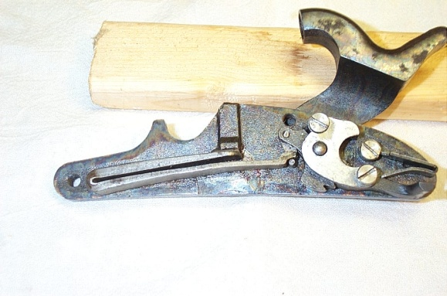
Step #4 – Carefully install the mainspring vice on the spring as shown. Don’t try to compress the spring any further, just install the vice and tighten the thumb screw until its snug.
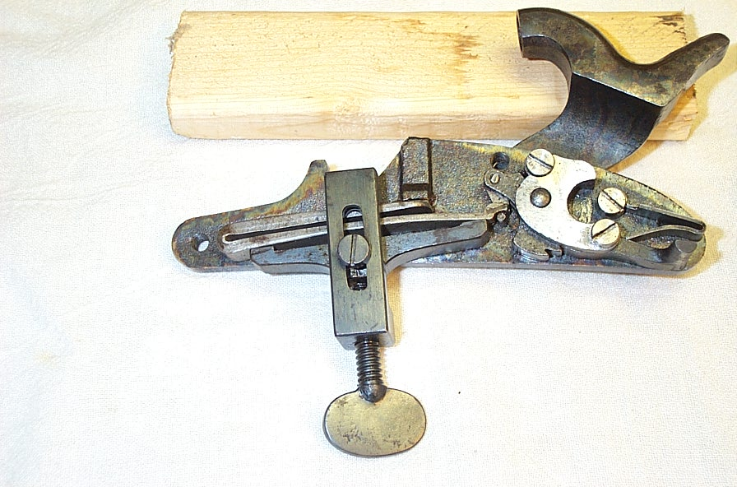
Step #6 – press up on the sear to release and lower the hammer to the rest position. The vice will hold the spring compressed and the hammer and tumbler will now move freely. Disengage the end of the spring from the stirrup. There is an alignment pin in the spring near the “U” shaped bend that goes in a hole in the lock plate. Now gently wiggle the spring and vice together back and forth, loosening the alignment pin. Carefully pull the spring off the lock plate as you wiggle it. The spring will pull free. Set the spring and vice aside, keeping the vice on the spring.
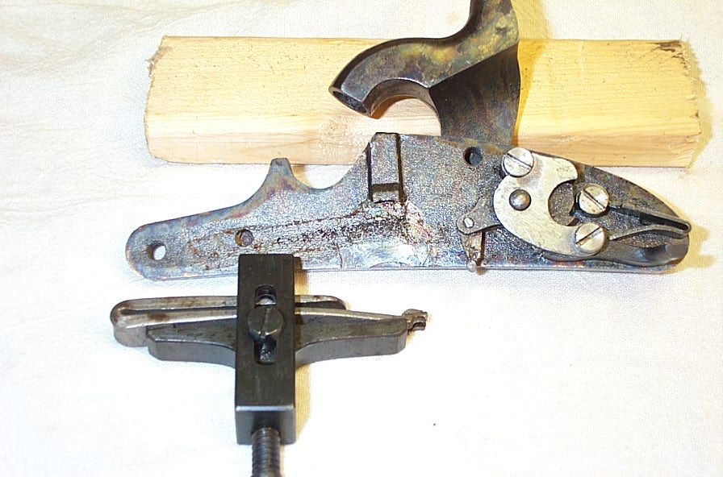
Step #7 – Using your musket tool screwdriver, loosen the sear spring screw about 1.5 turns only.
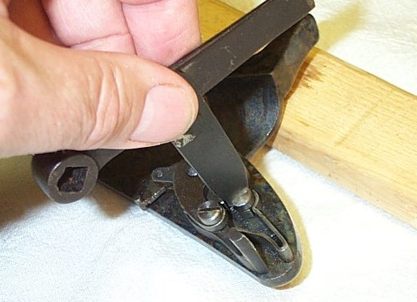

With the screw slightly loose, the sear spring which has a tab on the back that engages a slot in the lock plate, can now be pulled away from the slot and pulled up out of the way.
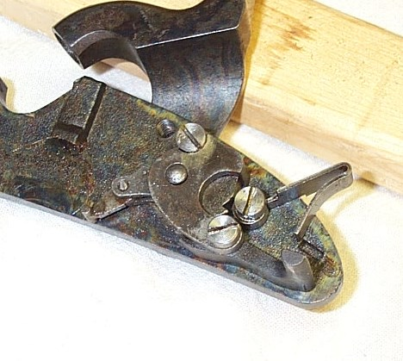
Now completely unscrew the sear spring screw and remove with the sear spring.

Step #8 – Unscrew the sear screw and remove the sear.
Step #9 – Unscrew and remove the last screw that holds the bridle in place. The bridle has an alignment pin on the back that goes in a hole in the lock plate.
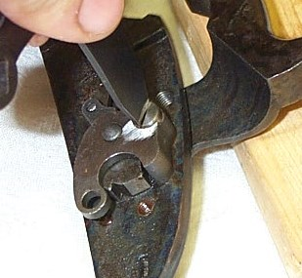
The bridle should just lift off, but if it has been a long time since it was removed, it may need a little gentle coaxing.
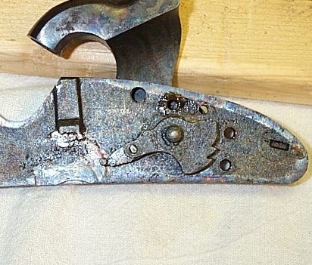
All that remains now is the tumbler. The tumbler has a round-to-square shank that goes through a hole in the lock plate. The hammer is a slight press fit on the square shank.
Step #9 – It’s time to remove the hammer. First the hammer screw needs to be removed.
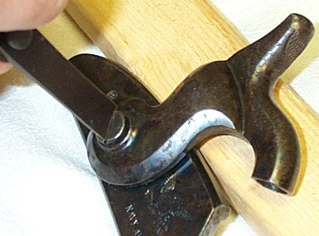
Step #10 – Place the lock between 2 pieces of solid wood, allowing the tumbler to hang down between them. You will be tapping the tumbler out of the hammer (not pulling the hammer off the tumbler). So the tumbler needs to be free to be driven out the bottom. Your wire and tumbler punch will be used or other suitable sized punch. On an original US army wire and tumbler punch, the larger of the two punches is the one to use here (refer to Musket tools part #2 in the previous newsletter for a refresher on this tool). The diameter of the punch should be slightly smaller than the threads in the hole. It is imperative that the punch used fit easily down inside the threaded hole without touching the threads. It will seat in the bottom of the hole. Now with your lock plate on the wooden blocks, straddling the tumbler and your punch in place, firmly tap the punch.
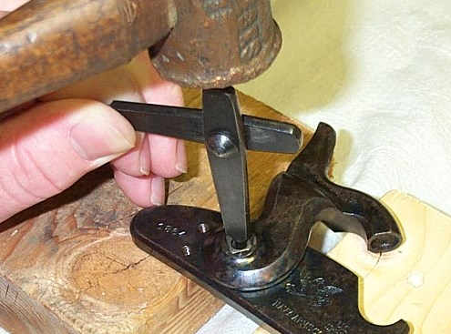
It may take a few solid taps to dislodge the tumbler. On original muskets there is a very slight taper to the square end of the tumbler. This allows the hammer to fit snugly and the tumbler to be removed with little effort. Italian repro muskets are not made to the same exacting standards and may not have the taper. However, with a few sharp taps, the hammer and tumbler should separate.
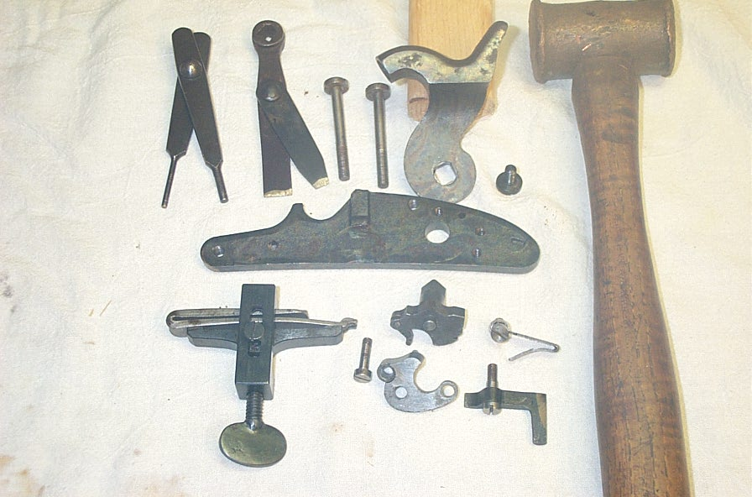

The lock is now completely disassembled and ready for cleaning and inspection. It wasn’t that hard now was it? In part #2 we will discuss how to clean the lock and what to look for when you inspect the parts.

