How Tight is Tight Enough?
Cpl Steve Blancard

Over the last 30 years I’ve worked on a lot of muskets and antique guns. If there is one common denominator among 90% of them, it’s that almost all have screws that were over tightened. In some cases this caused damage to the screw slot, screw threads or the wood.
The most common form of over tightening I see is with the 2 long side screws that hold the lock into the stock. These are sometimes tightened to the point of compressing the wood under the lock. This happens because over time, oil from the lock saturates the wood under the lock plate and can soften it. When lock screws are over-tightened, the lock plate is pulled against the narrow wood shoulder that supports the outer perimeter of the lock plate. If that wood is softened by oil and the screws are tightened too much, the wood will be compressed by the lock as it is drawn tight. This can cause a couple problems:
- First - the hammer may not strike the cone on center, but rather to the left side of it, possibly causing a misfire. If the edge of the hammer hits the cap rather than hitting in the recessed center of the hammer nose, the exploding cap fragments will not be as well contained and can result in fragments flying into the cheek of the next man in line. Odds are he will not be very happy about that.
- Second – The long lock screws are made to a precise length. When the lock is properly tightened, the end of the screw should be flush with or just shy of flush with the outer surface of the lock plate. If the lock screws are over tightened and the lock plate pulled too far in, the screws may extend beyond the surface of the lock plate. This isn’t a problem with the forward screw. But the rear screw can interfere with the fall of the hammer, again causing misfires.
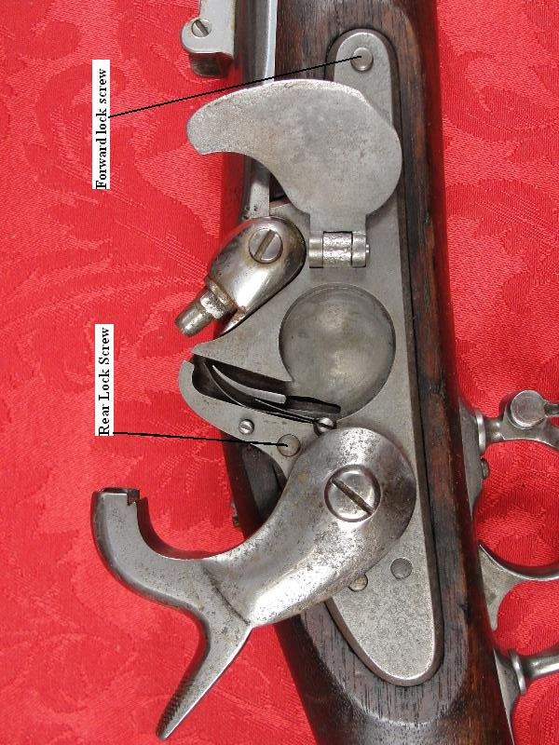
In this photo of an original model 1855 rifle musket the forward lock screw (far right) is protruding beyond the surface of the lock plate. The rear screw is just flush.
The other thing that is often over tightened is the cone. I’m sure many of you have seen or heard about someone who couldn’t get the cone out of their musket. This is not uncommon in original; muskets that have not been touched in many years - corrosion adds to the difficulty. But on reproduction muskets there is no excuse for having a stuck cone. Using a properly fitting cone wrench is essential.
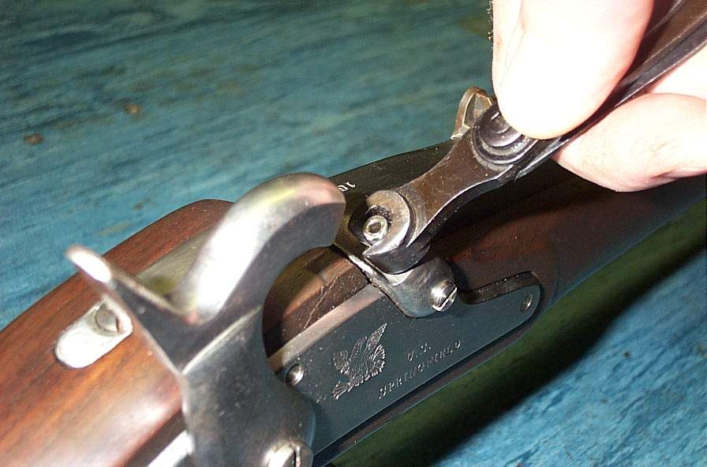
Note the properly fitting cone wrench and the 2 long lock screws are just below the surface of the lock plate.

So, how tight is tight enough? Well, most of us don’t have torque screwdrivers in our kits, so the best way I can answer is with one word - “snug”. Whether it’s a lock screw or cone, it should be turned in with a properly fitting screwdriver or wrench until you feel it just seat firmly and stop. That should be snug. Anything more than that is likely to do more harm than good.
Speaking of correct tools, a properly fitted standard issue musket wrench appropriate for your musket is all you need for field maintenance. Here is a model 1855 rifle musket tool. It has a wrench for the cone and three screwdriver blades.
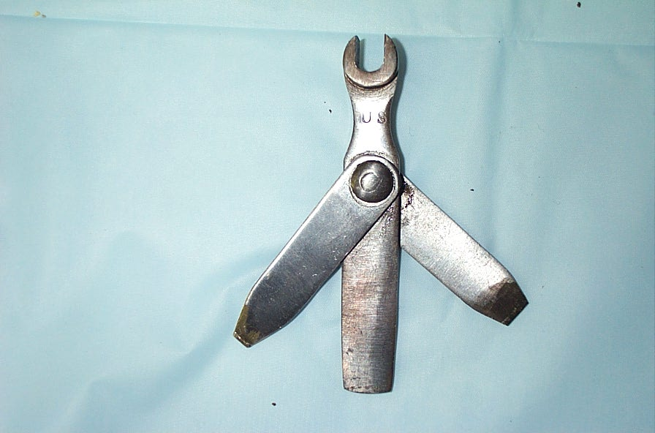
Model 1855 musket tool
Look closely at the three blades on the musket tool. Do you know what each is for? The blade to the left is for the flash channel clean out screw on model 1855 and 1861 Springfield pattern muskets. It is very small and narrow to fit the tiny screw.
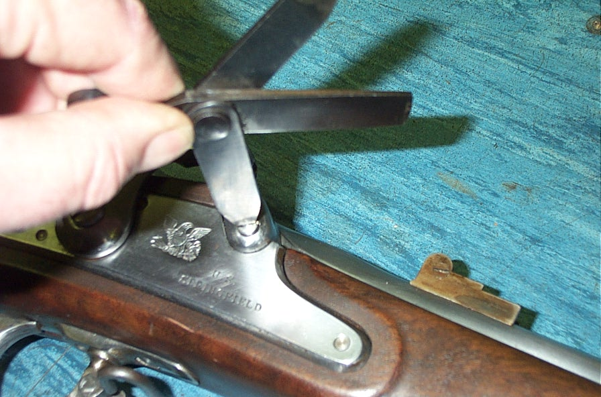
The smallest blade fits the clean out screw.

Refer to the musket tool photo again, look at the middle blade – notice anything odd about it? The end of the blade is slightly convex, or rounded. Hmmm, why is that you wonder? Ahh, the US Army Ordnance department was actually pretty smart. The original large wood screws that hold the butt plate on have slots in them that were plunge cut with a large diameter cutting wheel. The radius of that wheel left the bottom of the screw slot slightly concave rather than flat. The convex screwdriver blade is the same radius and matches the slot in the bottom of the screw head. These screws were pretty tight and they wanted the screwdriver blade to fit perfectly to avoid slipping out of the slot.
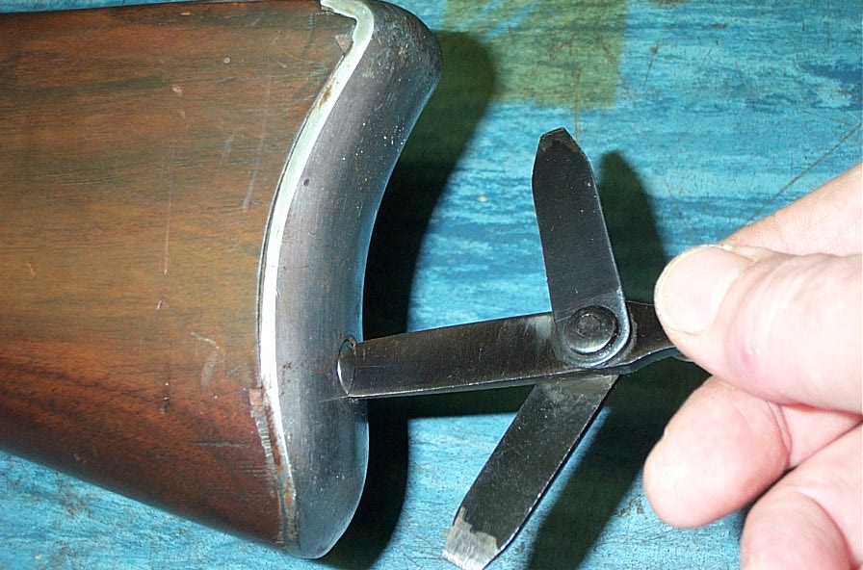
The blade with a convex end is for the butt plate screws.

Again referring to the musket tool above, the blade on the right side is of medium size with a straight end. It is for the lock, tang and trigger guard screws.
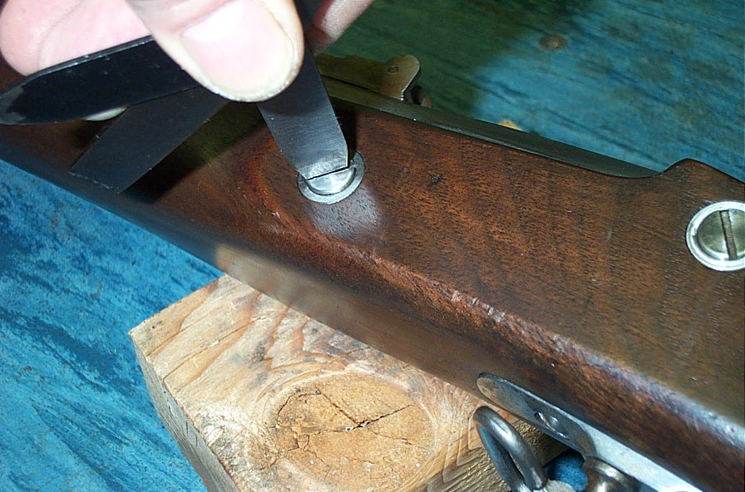
The medium size blade is for the lock, tang and trigger guard screws.

You may find that your reproduction musket tool will not fit your reproduction musket screws. Reproduction tools vary in quality of manufacture, but are supposed to fit original musket screws – sometimes they do and sometimes they don’t. Unfortunately the Italians often use screw slots that are narrower than originals and this creates a problem when trying to use the tool. I often take reproduction musket tool blades and carefully grind them narrower to fit the screws of reproduction muskets. This is easy to do and once completed, a fully functional musket tool results. That’s all I use for field cleaning and maintenance of my musket when at an event.
Until next time – keep your musket clean and screws snug!

